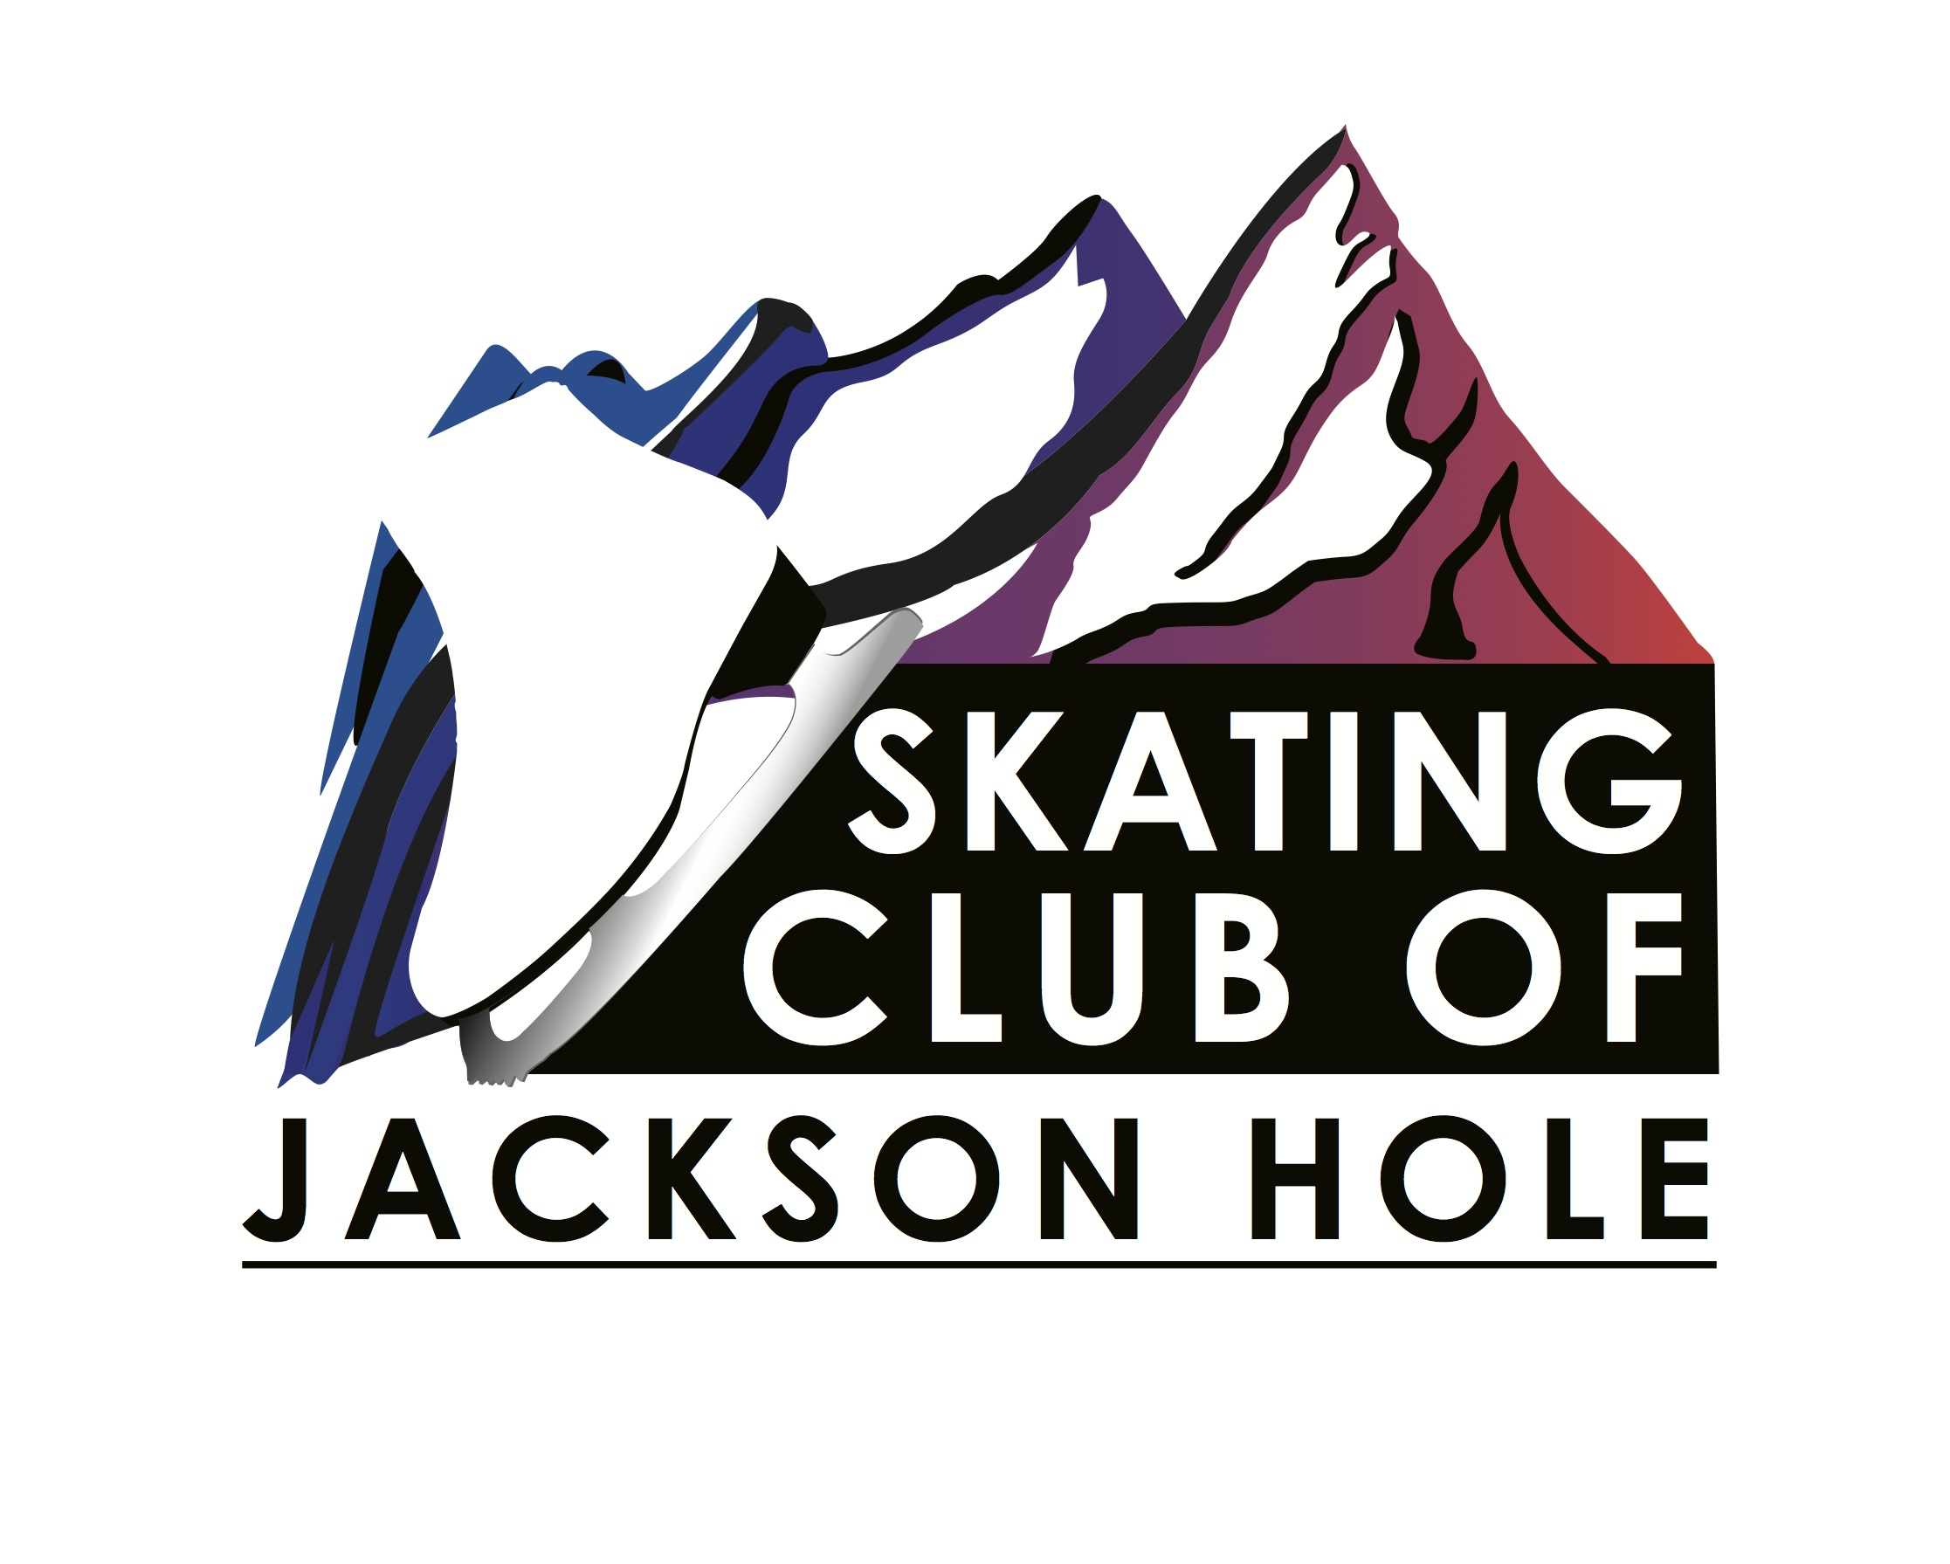
Participant Information:
Last:_________________________First:___________________ DOB:______
Address:____________________________________________

Photographic Release

I hereby grant the Skating Club of Jackson Hole the right and permission, with respect to photographs and videos taken of the minor named below on whose behalf I am signing, and with respect to any printed matter in connection therewith, to do the following:

To include such photographs and or video, but not first or last names, in newsletters, blogs, website, social media and print materials.

I hereby release, discharge and agree to indemnify and hold harmless Skating Club of Jackson Hole from all claims and demands whatsoever arising out of or in connection with the foregoing and waive any right to inspect or approve the same.

I hereby certify that I am the parent or legal guardian of______________________________, a minor under the age of eighteen years and hereby consent on behalf of said minor to the use of any of the photographs taken of said minor pursuant to the terms set forth in the Photographic Release including without limitations the release, discharge and hold harmless provisions thereof.

_____________________________________________________________
Printed name of Parent or Guardian

_____________________________________________________________
Signature of Parent or Guardian of Minor
Subject of Photograph

